实验报告
一、实验目的
用雅克比迭代法求解下列线性方程组的解：
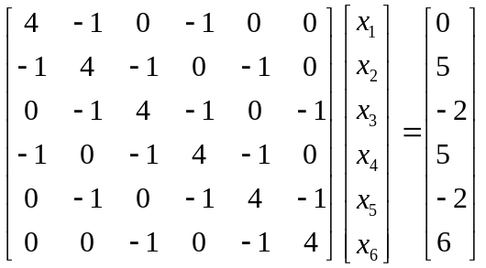
- 分析并证明收敛性；
- 编程求出使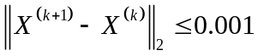的近似解以及相应的迭代次数；
- 用MATLAB绘制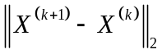的时间变化曲线。

二、实验方法（要求用自己的语言描述算法）
雅克比迭代法相对别的方法比较传统而且较简易，提高了运算效率。基本思想是联立方程组的求解，通过重复计算一组彼此独立的线性表达式，来逐步求得解，使得求解过程变简单。

1）解线性方程组，可以使用雅可比迭代方程。使用雅可比迭代法收敛的条件是的谱半径小于1，即。其必要条件是的任意一个范数小于1。
我们求的1范数，即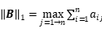
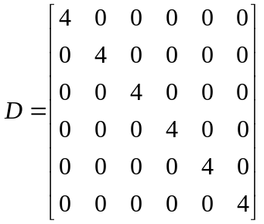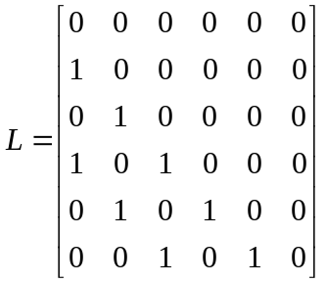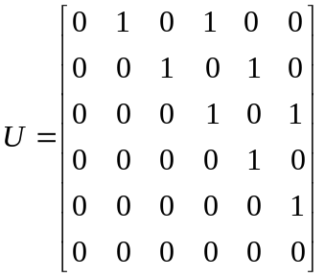
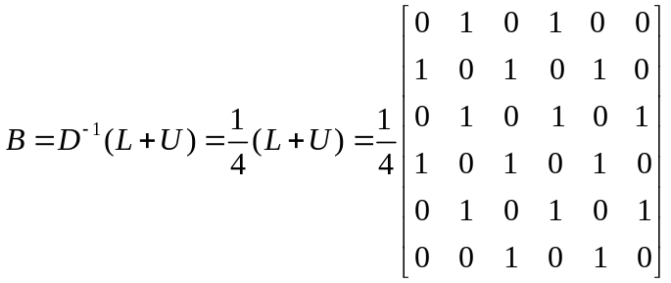
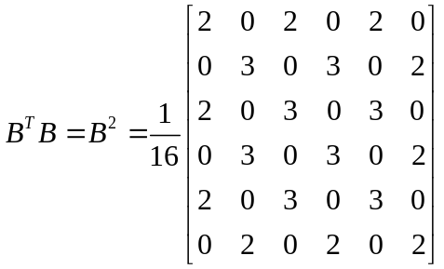 。
因此可以得到雅可比迭代式是收敛的。

三、实验代码
Main.cpp
#include <iostream>
#include "matrix.h"
#include <vector>
using namespace std;
int main() {
matrix A = {
{4, -1, 0, -1, 0, 0},
{-1, 4, -1, 0, -1, 0},
{0, -1, 4, -1, 0, -1},
{-1, 0, -1, 4, -1, 0},
{0, -1, 0, -1, 4, -1},
{0, 0, -1, 0, -1, 4}
};

matrix b = {
{0},
{5},
{-2},
{5},
{-2},
{6}
};

A.print_with_title("A");
matrix D = A.get_dialog();
matrix B = (D ^ -1) * (D - A);
B.print_with_title("B");
matrix f = (D ^ -1) * b;
matrix x0 = {{1},{1},{1},{1},{1},{1}};
matrix x1 = x0;
double eps = 0.001;
double ir = 0;
vector<double> results;
do{//++index;
x0 = x1;
x1 = B * x0 + f;
ir = (x1 - x0).vector_norm2();
results.emplace_back(ir);
} while(ir > eps);

x1.print_with_title("x = ");

int length = results.size();
cout << "x = [";
for (int i = 0; i < length; ++i) {
cout << (i + 1) << " ";
}
cout << "]" << endl << "y = [";
for (int i = 0; i < length; ++i) {
cout << results[i] << " ";
}
cout << "]" << endl;
return 0;
}

matrix.h
#pragma once
#include <iostream>
#include <iomanip>
#include <string>
#include <initializer_list>
#include <sstream>
using namespace std;

class matrix {
public:
matrix(initializer_list<initializer_list<double>> data){
get_row_column(data, _row_count, _column_count);
fill(data, fills, _row_count, _column_count);
}
matrix(const matrix& m){
_is_error = m._is_error;
_row_count = m._row_count;
_column_count = m._column_count;
fills = new double[_row_count * _column_count];
for (int i = 0; i < _row_count * _column_count; ++i) {
fills[i] = m.fills[i];
}
}
int row_count() { return _row_count; }
int column_count() { return _column_count; }
void print(int w = 8);
void print_with_title(const string& title, int w = 8);
double vector_norm2();

matrix t();
matrix get_dialog();

~matrix(){
if(fills != nullptr){
delete[] fills;
}
}
friend matrix operator + (const matrix& m1, const matrix& m2);
friend matrix operator - (const matrix& m1, const matrix& m2);
friend matrix operator * (const matrix& m1, const matrix& m2);
friend matrix operator ^ (const matrix& m1, int p);

matrix& operator = (const matrix& m);
matrix& operator -();
static matrix error_instance(){
matrix m(0,0);
m._is_error = true;
return m;
}
static matrix e(int row);
static matrix dialog(initializer_list<double> data);

private:
matrix(int _row_count, int _column_count): _row_count(_row_count), _column_count(_column_count){}
static void get_row_column(initializer_list<initializer_list<double>>& data, int& row_count, int& column_count);
static void fill(initializer_list<initializer_list<double>>& data, double*& fills, int& row_count, int& column_count);
static void fill(double*& data, int length);
matrix inverse() const;
bool is_dialog() const;

bool _is_error = false;
int _row_count;// 行数
int _column_count;// 列数
double* fills = nullptr;//填充
};

matrix.cpp
#include <cmath>
#include "matrix.h"
void matrix::get_row_column(initializer_list<initializer_list<double>>& data, int &row_count, int &column_count) {
row_count = data.size();
int max_column = data.begin()->size();
for(auto p: data){
if(p.size() > max_column){
max_column = p.size();
}
}column_count = max_column;
}

void matrix::fill(initializer_list<initializer_list<double>> &data, double*& fills, int &row_count, int &column_count) {
fills = new double[row_count * column_count];
int i = 0;
for(auto p1: data){
int j = 0;
for(auto p2: p1) fills[i * column_count + j++] = p2;
while(j < column_count){
fills[i * column_count + j++] = 0;
}++i;
}
}

void matrix::print(int w) {
int fill1 = 2;
if(_is_error) cout << "error!matrix" << endl;
else {for (int i = 0; i < _row_count; ++i) {
for (int j = 0; j < _column_count; ++j) {
cout << setw(w) << fills[i * _column_count + j];
} cout << endl;
}
}
}

void matrix::print_with_title(const string& title, int w) {
int title_fill = title.size();
int n_fill = 4;
if(_is_error){
cout << title << " = error!matrix" << endl;
} else {
for (int i = 0; i < _row_count; ++i) {
cout << setw(title_fill);
if (i == 0) {
cout << title;
} else {
cout << " ";
}
cout << setw(n_fill);
if (i == 0) {
cout << " = [";
} else {
cout << " ";
}
for (int j = 0; j < _column_count; ++j) cout << setw(w) << fills[i * _column_count+j];
if (i == _row_count - 1) cout << " ]";
cout << endl;
}
}
}

matrix matrix::t() {
matrix m(_column_count, _row_count);
m.fills = new double[_row_count * _column_count];
for (int i = 0; i < _row_count; ++i) {
for (int j = 0; j < _column_count; ++j) {
m.fills[j * _row_count + i] = fills[i * _column_count + j];
}
} return m;
}

matrix operator+(const matrix &m1, const matrix &m2) {
if(m1._row_count == m2._row_count && m1._column_count == m2._column_count){
int row = m1._row_count;
int column = m1._column_count;
matrix m(row, column);
m.fills = new double[row * column];
for (int i = 0; i < row; ++i) {
for (int j = 0; j < column; ++j) {
m.fills[i * column + j] = m1.fills[i * column + j] + m2.fills[i * column +j];
}
} return m;
} else return matrix::error_instance();
}

matrix &matrix::operator-() {
for (int i = 0; i < _row_count * _column_count; ++i) {
fills[i] = - fills[i];
}return *this;
}

matrix operator-(const matrix &m1, const matrix &m2) {
matrix right = m2;
return m1 + (-right);
}

matrix operator*(const matrix &m1, const matrix &m2) {
if (m1._column_count == m2._row_count) {
int row = m1._row_count;
int column = m2._column_count;
matrix m(row, column);
m.fills = new double[row * column];
for (int i = 0; i < row; ++i) {
for (int j = 0; j < column; ++j) {
double v = 0;
for (int k = 0; k < m1._row_count; ++k) {
v += m1.fills[i * m1._column_count + k] * m2.fills[k * m2._column_count+j];
}m.fills[i * column + j] = v;
}
}return m;
} else return matrix::error_instance();
}

matrix matrix::e(int row) {
matrix m(row, row);
m.fills = new double[row * row];
fill(m.fills, row*row);
for (int i = 0; i < row; ++i) {
m.fills[i] = 1;
}
return m;
}

matrix matrix::dialog(initializer_list<double> data) {
int row = data.size();
matrix m(row, row);
m.fills = new double[row * row];
fill(m.fills, row*row);

int i = 0;
for(auto p: data){
m.fills[i * row + i] = p;
++i;
}
return m;
}

void matrix::fill(double*& data, int length) {
for (int i = 0; i < length; ++i) {
data[i] = 0;
}
}

matrix matrix::get_dialog() {
if(_row_count == _column_count){
int row = _row_count;
matrix m(row, row);
m.fills = new double [row * row];
fill(m.fills, row * row);
for (int i = 0; i < row; ++i) {
m.fills[i * row + i] = fills[i * row + i];
}
return m;
} else {
return matrix::error_instance();
}
}

matrix matrix::inverse() const {
if(_row_count != _column_count){
return matrix::error_instance();
}
int row = _row_count;
if(is_dialog()){
matrix m(row, row);
m.fills = new double[row * row];
fill(m.fills, row * row);
for (int i = 0; i < row; ++i) {
m.fills[i * row + i] = 1.0 / fills[i * row + i];
}
return m;
} else {
return *this;
}
}

bool matrix::is_dialog() const {
if(_row_count != _column_count){
return false;
}
for (int i = 0; i < _row_count; ++i) {
for (int j = 0; j < _column_count; ++j) {
if(i != j && fills[i * _column_count + j] != 0){
return false;
}
}
}
return true;
}

matrix operator^(const matrix& m, int p) {
if(m._row_count != m._column_count){
return matrix::error_instance();
}
if(p == 0){
return matrix::e(m._row_count);
} else if(p > 0){
matrix a = m;
for (int i = 2; i <= p; ++i) {
a = a * m;
}
return a;
} else {
matrix l = m.inverse();
matrix a = l;
for (int i = 2; i <= -p; ++i){
a = a * l;
}
return a;
}
}

matrix &matrix::operator=(const matrix &m) {
_is_error = m._is_error;
_row_count = m._row_count;
_column_count = m._column_count;
if(fills != nullptr){
delete[] fills;
fills = nullptr;
}
fills = new double[_row_count * _column_count];
for (int i = 0; i < _row_count * _column_count; ++i) {
fills[i] = m.fills[i];
}
return *this;
}

double matrix::vector_norm2() {
if(_row_count == 1 || _column_count == 1){
int length = _row_count * _column_count;
double v = 0;
for (int i = 0; i < length; ++i) {
v += fills[i] * fills[i];
}
return sqrt(v);
}
return -1;
}

matlab脚本
clear
clc
figure()
x = [1 2 3 4 5 6 7 8 9 10 11 12 13 14 15 16 17 18 19 20 21 22 ];
y = [2.09165 1.41973 0.969254 0.661991 0.452147 0.308822 0.21093 0.144068 0.0984 0.0672084 0.0459042 0.0313532 0.0214146 0.0146265 0.00999005 0.00682333 0.00466042 0.00318313 0.00217412 0.00148495 0.00101424 0.000692738 ];
plot(x,y,'-.r*')

四、实验结果及其讨论
程序执行结果.
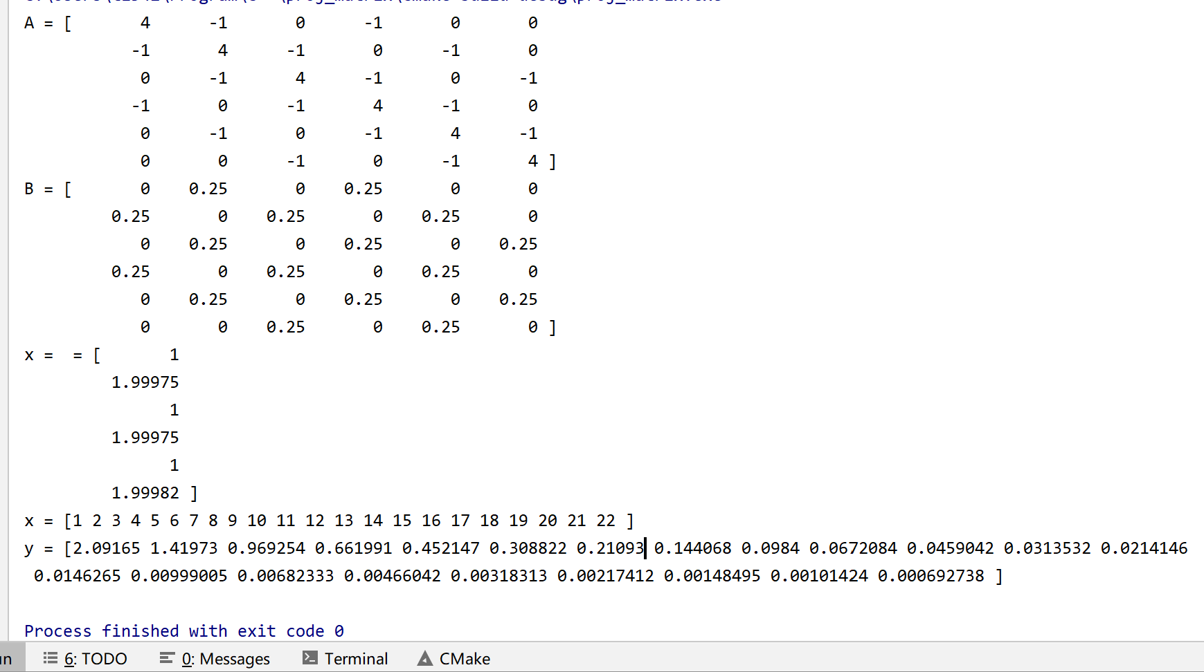
MATLAB绘制图形.
1.次数-误差曲线:
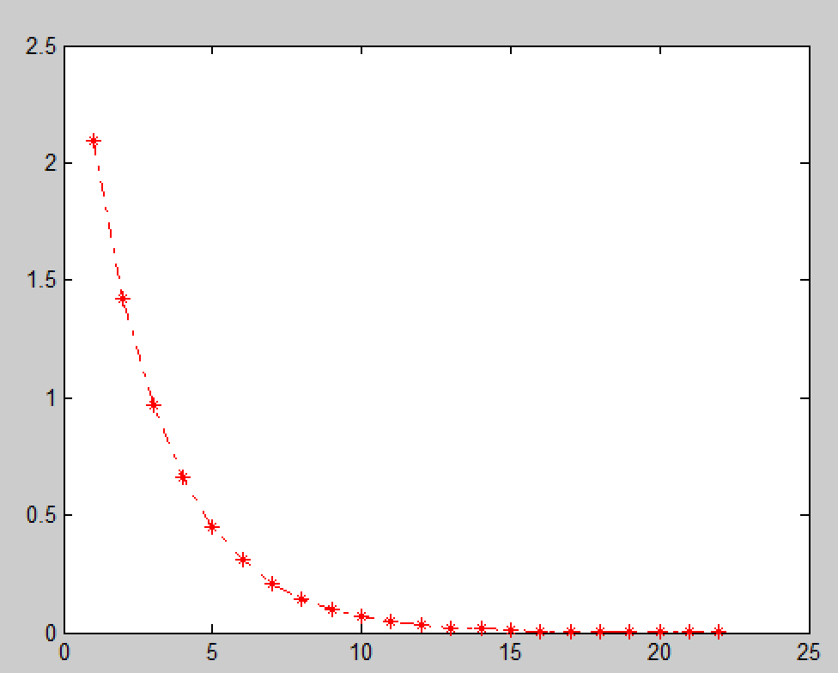

2.次数-误差-ln(误差)曲线:
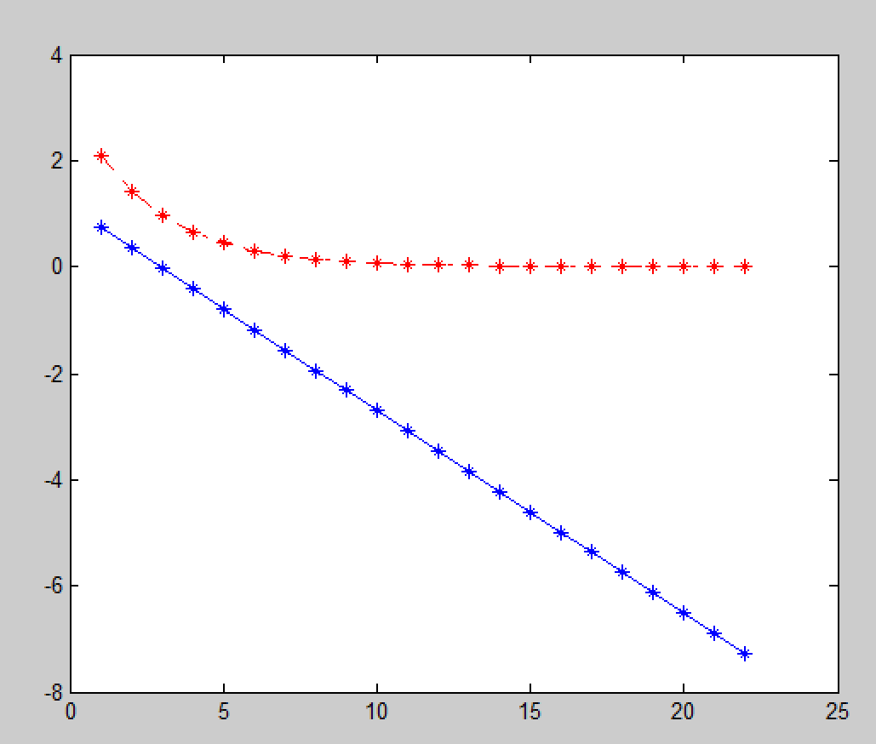

讨论.
（1）误差
本实验从向量开始迭代。从输出结果中可以看出，当迭代次数k增大时,迭代值会越来越逼近方程组的精确解,最后到达精度的解为 ，符合精度的要求，猜测精确解为.
第3个图可见，雅可比迭代法的精度呈现指数下降的规律，越到后面精度下降越慢。因此在计算简单的方程组的解时，使用主元高斯消元法更加快一些。
（2）收敛性
在本题目中, 用雅可比迭代法求解该线性方程组，得到的近似根是收敛的。

- 总结
优点：雅可比迭代法算法简单，编制程序比较容易。可以发现，雅可比迭代适合大规模的矩阵求解(一般没有精确解)。
缺点：雅可比迭代法要求方程组的系数矩阵有某种特殊性质（比如对角占优阵）以保证过程的收敛性。

